Twitter Massing

Profile System- Admin will create a profile for users to login X Amounts of Twitter accounts.

To follow /UNfollow users daily.

With a similar schedule to this - 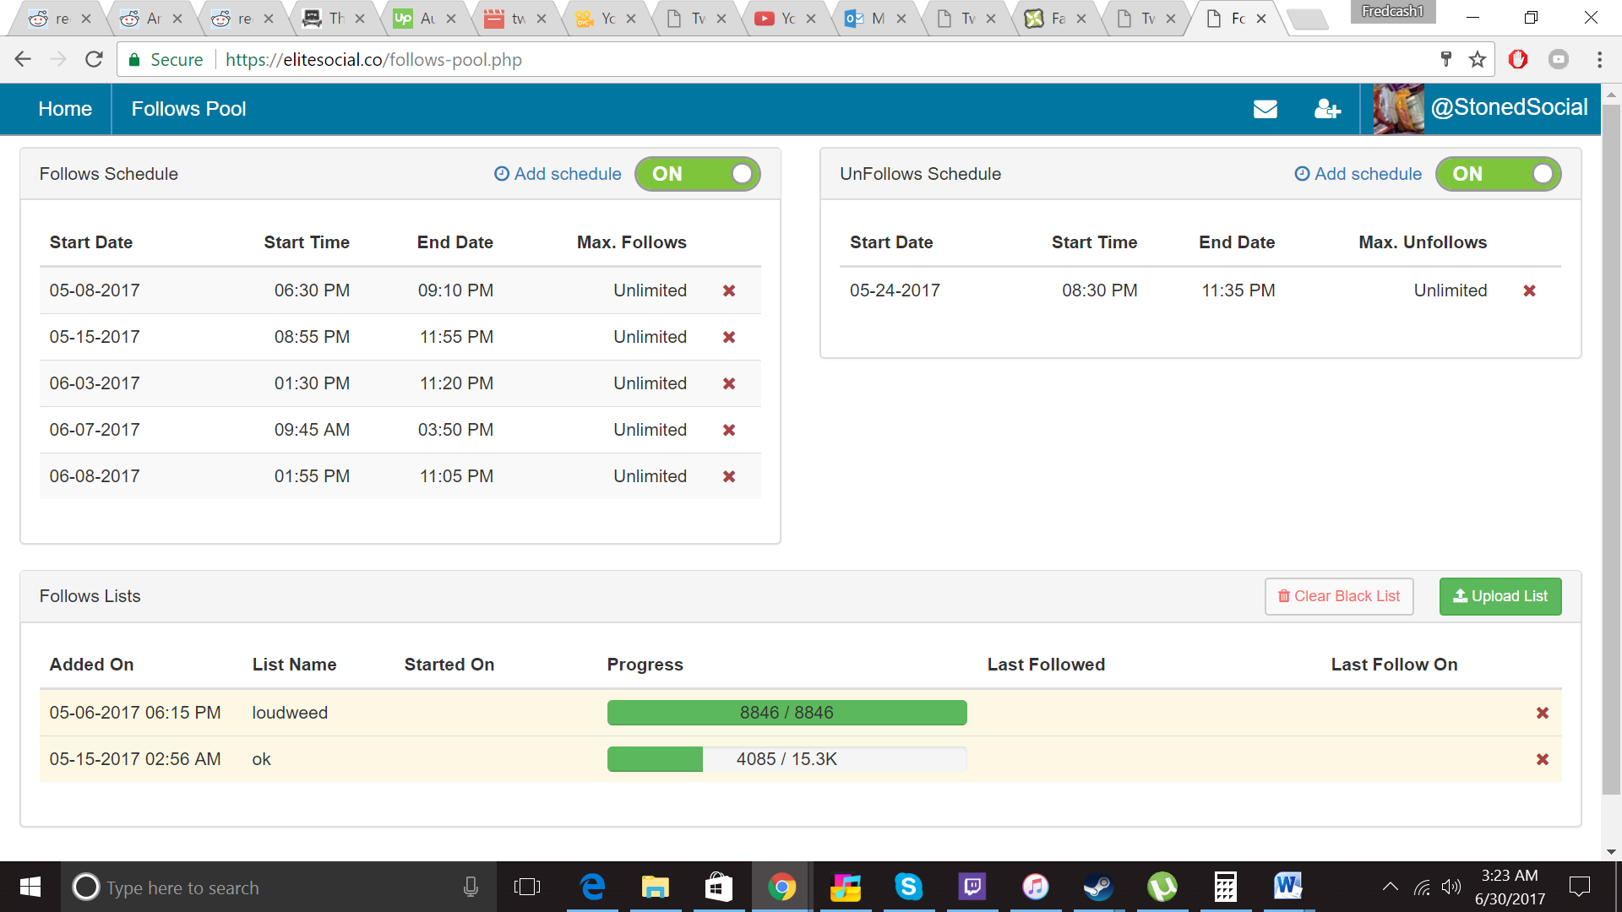

Follow lists are the pooled lists of filtered accounts we will follow.

On the most recent date, for sending follows, the system will repeat the day schedule whether there are 1 or 2 time slots for that day. (Possibly more)

Unfollows will start on their set date and cancel the follows schedule

To resume add a new follow schedule that will start after unfollows should be done.

ADMIN page will just have simple profile management for adding new customers accounts.